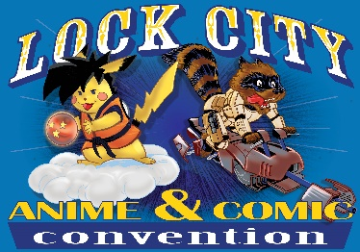
Best Western September 5, 2020 EXHIBITOR REGISTRATION FORM

Please sign and complete the entire form and return to: Attn: Bernie Berube, 19 Pearl St, Plainville, Ct 06062. Scanned forms can be sent to: lockcityacc@gmail.com.
Each dealer table is 6 feet long, all tables come with two chairs and linen and 2 passes. Extra passes are $5 for vendors. Show hours are: Saturday 10am to 5pm. Setup day is the 5th from 6 am till 9am.

Vendor Table Price: $85 | ____ # of tables x price = $ _______
Artist Table Price: $ 75 | ____ # of tables x price = $ _______
 | ____ # of tables x price = $ _______
Electricity is limited to a first come first serve basis  Check before you add on. | Electric: ($25) ________________

Payments can be made through our website squareup.com/store/lockcity
Payment must be made in full and accompanied by your registration form before you are allowed to set up on the floor. All tables are considered available for sale until full payment is made. Setup info is located on the website, we do not email setup info. No refunds are given for an exhibitor not showing up. All exhibitors must be set up by 9am.No one will be allowed to setup after that.
Company: _________________________________________ Contact: _______________________
Address: ___________________________________________________________________________
City: ___________________________ State: _________________________ Zip: _____________
Phone: ____________________ E-Mail _________________________________________________
Website: ___________________________________________________________________________ ______________________________ Facebook: _________________________________
CANCELLATIONS: No refunds will be given.
HOLD HARMLESS: By agreeing to exhibit at Lock City Comic Con, the dealer agrees to protect, keep and save Lock city comic con L.L.C and The Best Western forever harmless from any damage, loss, theft, cost, liability or expense that arises from their exhibiting at this show. This agreement covers full setup, run of the show and teardown. By signing below you are indicating your approval of all information contained. Lock city comic con is not responsible for amount of sales at the show. Refunds and credits will not be given due to lack of sales.
Signed: ___________________________________________ Date: ________________________

Lock City Comic Con llc
lockcityacc@gmail.com facebook.com/lockcitycomiccon instagram@lockcityanime

